ASSEMBLY INSTRUCTIONS

Auburn Floor Lamp (Item#:MP154-0200)

Important Safety Instructions:
- For safety purpose, this lamp is equipped with a polarized plug (one blade is wider than the other). If the plug does not fit securely into your outlet, do not force it, contact a professional electrician. Never alter the plug in any way.
- These instructions are provided for your safety. It is very important that they are read carefully and completely before assembling fixture.
- This fixture has been rated for up to (1) 60-watt maximum TYPE A bulb or (1) 13-watt compact fluorescent light bulb. To avoid the risk of fire, do not exceed the recommended wattage.

Pre-assembly:
- Do not discard any contents until after assembly is complete to avoid accidentally discarding small parts or hardware.
- Remove all parts and hardware from box along with any plastic protective packaging.
Parts Enclosed:

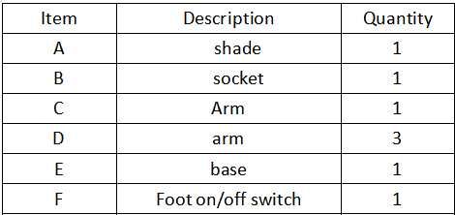

Warning:
- Wires and cables are all attached (further wiring is not needed from consumer). When unpacking product, be careful to not pull wires as it may result as a bad connection. Do not plug into electrical outlet until lamp is fully assembled.
- Note:

Turn the power off (unplug from the wall outlet) before replacing the bulb. Make sure the bulb has sufficient time to cool down.

Assembly Instruction:

Step1. Unpack and place all parts on a surface or floor.
Step2. Put Lamp Base (E) on a Flat surface.
Step3. Screw the shade (A) to Arm(C) .
Step 4. Connect to 3pcs arm D step by step.
Step 5. Screw whole body to base (E).
Step 6. Assembly is completed.

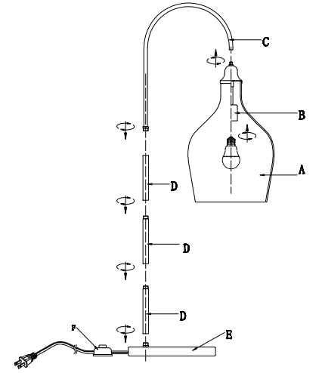

Care instructions:
• Wipe with soft dry cloth only
• Always avoid the use of harsh chemicals or abrasive as they may damage to the finish.

Thank you for your purchase

