
ASSEMBLY INSTRUCTIONS
Auburn Table Lamp (Item# FB153-1175)
Important Safety Instructions:
- For safety purpose, this lamp is equipped with a polarized plug (one blade is wider than the other). If the plug does not fit securely into your outlet, do not force it, contact a professional electrician. Never alter the plug in any way.
- These instructions are provided for your safety. It is very important that they are read carefully and completely before assembling fixture.
- This fixture has been rated for up to (1) 40-watt maximum TYPE B bulbs (not included) or (1) 9-watt compact fluorescent light bulbs (not included). To avoid the risk of fire, do not exceed the recommended wattage.
- This lighting fixture is intended for indoor, residential use.

Warning:
- Wires and cables are all attached (further wiring is not needed from consumer). When unpacking product, be careful to not pull wires as it may result as a bad connection. Do not plug into electrical outlet until lamp is fully assembled.
- To reduce the risk of fire, electrical shock or personal injury, do not turn on lighting fixture until light bulb is installed and assembly is complete.
- Always turn off the lighting fixture and allow it to cool before replacing the light bulb.

Care instructions:
- Wipe with soft dry cloth only.
- Always avoid the use of harsh chemicals or abrasive as they may damage.

Page 1 of 2

Pre-assembly:
- Remove all parts and hardware from box along with any plastic protective packaging.
- Check that all parts listed are included.
- Do not discard any contents until after assembly is complete to avoid accidentally discarding small parts or hardware.

Component List
Part Code | Component | Description | Qty
A | 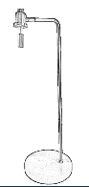 | Body | 1
B | 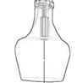 | Shade | 1
C | 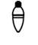 | Bulb | Not included
D | 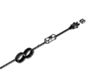 | Wire with switch | 1

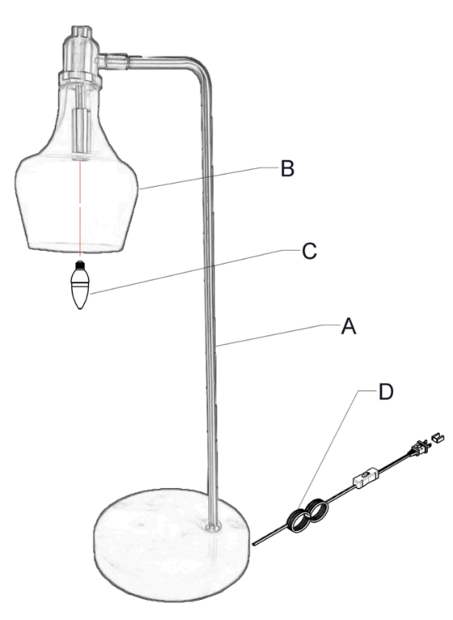

Assembly Instructions:

Step1. Unpack and place all parts on a surface or floor.

Step2. Put the lamp on the table. Gently screw the bulb (not included) to the socket.

Step3. Assembly is completed.

Thank you for your purchase

