
ASSEMBLY INSTRUCTIONS

CLYDE FLOOR LAMP (Item#:MT154-0050)

Important Safety Instructions:
- For safety purpose, this lamp is equipped with a polarized plug (one blade is wider than the other). If the plug does not fit securely into your outlet, do not force it, contact a professional electrician. Never alter the plug in any way.
- These instructions are provided for your safety. It is very important that they are read carefully and completely before assembling fixture.
- This fixture has been rated for up to (1) 60-watt maximum TYPE A bulb or (1) 13-watt compact fluorescent light bulb. To avoid the risk of fire, do not exceed the recommended wattage.

Pre-assembly:
- Do not discard any contents until after assembly is complete to avoid accidentally discarding small parts or hardware.
- Remove all parts and hardware from box along with any plastic protective packaging.
Parts Enclosed:
Item | Decription | Quantity
A | shade | 1
B | Metal rod | 6
C | Lamp base | 1
D | Foot on/off switch | 1
E | Socket ring | 1

Warning:
- Wires and cables are all attached (further wiring is not needed from consumer). When unpacking product, be careful to not pull wires as it may result as a bad connection. Do not plug into electrical outlet until lamp is fully assembled.

- Note:

Turn the power off (unplug from the wall outlet) before replacing the bulb. Make sure the bulb has sufficient time to cool down.

Assembly Instruction:

Step1. Unpack and place all parts on a surface or floor.
Step2. Put Lamp Base (C) on a Flat surface.
Step 3. Connect 6 pcs (2 sets) metal rods (B) to the base(C) step by step.
Step 4. Place the Shade(A) onto top of the socket (B) and tighten with socket ring (E).
Step 5. Screw light bulb into the Socket.
Step 6.Assembly is completed.
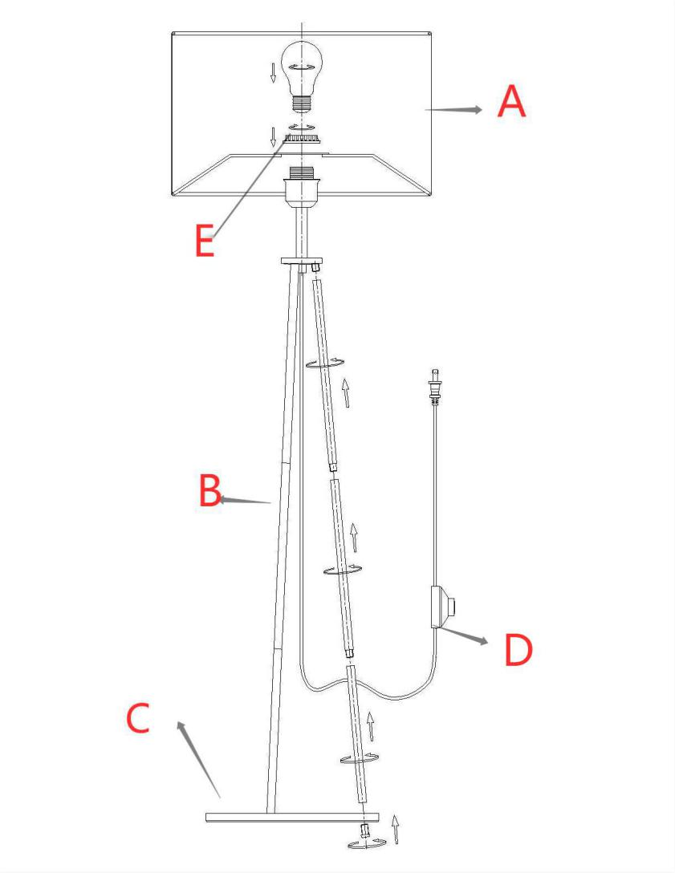

Care instructions:
• Wipe with soft dry cloth only
• Always avoid the use of harsh chemicals or abrasive as they may damage to the finish.

Thank you for your purchase

