
ASSEMBLY INSTRUCTIONS
Doyer Table Lamp (Item#MT153-0068)

Important Safety Instructions:
- For safety purpose, this lamp is equipped with a polarized plug (one blade is wider than the other). If the plug does not fit securely into your outlet, do not force it, contact a professional electrician. Never alter the plug in any way.
- These instructions are provided for your safety. It is very important that they are read carefully and completely before assembling fixture.
- This fixture has been rated for up to (1) 60-watt maximum TYPE A bulb or (1) 13-watt compact fluorescent light bulb . To avoid the risk of fire, do not exceed the recommended wattage.
- This lighting fixture is intended for indoor, residential use.

Warning:
- Wires and cables are all attached (further wiring is not needed from consumer). When unpacking product, be careful to not pull the wires as it may result in a bad connection. Do not plug into electrical outlet until lamp is fully assembled.
- To reduce the risk of fire, electrical shock, or personal injury, do not turn on lighting fixture until light bulb is installed and assembly is complete.
- Always turn off the lighting fixture and allow it to cool before replacing the light bulb.

Care instructions:
- Wipe with soft dry cloth only.
- Always avoid the use of harsh chemicals or abrasives as they may damage the finish.

Page 1 of 3

Pre-assembly:
- Remove all parts and hardware from box along with any plastic protective packaging.
- Check that all parts listed are included.
- Do not discard any contents until after assembly is complete to avoid accidentally discarding small parts or hardware.

Component List
Part Code | Component | Description | Qty
A | Base | already assembled | 1
B | 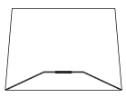 | Shade | 1
C | 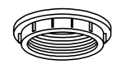 | Socket lock ring | 1
D | 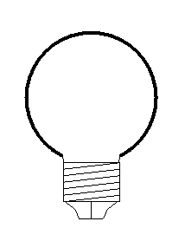 | Bulb | Not included

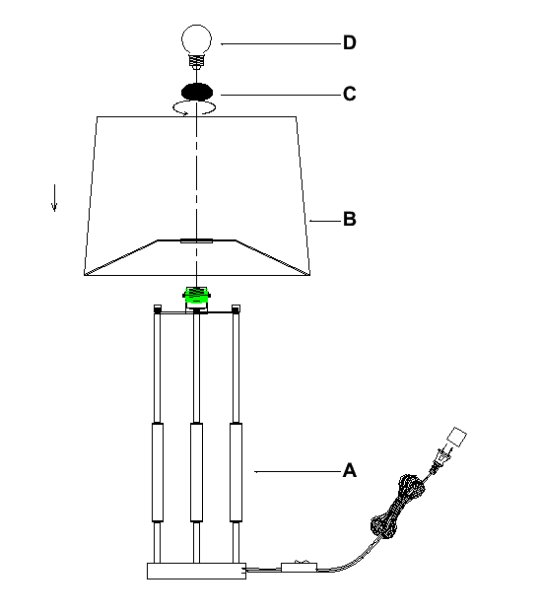

Assembly Instruction:
Step1: Place the lamp shade (B) downward onto the base (A) secure tightly with the socket lock ring (C). Lastly, install the bulb (bulb not included).
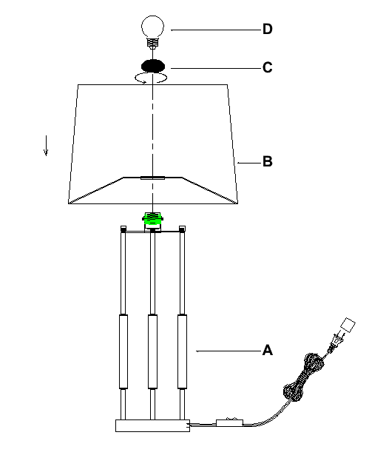
Thank you for your purchase

