

ASSEMBLY INSTRUCTIONS
Arbios Perforated Pattern Pendant (Item# II151-0143)
Important Safety Instructions:
- For safety purpose, this lamp is equipped with a polarized plug (one blade is wider than the other). If the plug does not fit securely into your outlet, do not force it, contact a professional electrician. Never alter the plug in any way.
- These instructions are provided for your safety. It is very important that they are read carefully and completely before assembling fixture.
- This fixture has been rated for up to (1) 60-watt maximum TYPE A bulb (not included) or (1) 13-watt compact fluorescent light bulb (not included). To avoid the risk of fire, do not exceed the recommended wattage.
- This lighting fixture is intended for indoor, residential use.

Warning:
- Wires and cables are all attached (further wiring is not needed from consumer). When unpacking product, be careful to not pull wires as it may result as a bad connection. Do not plug into electrical outlet until lamp is fully assembled.
- To reduce the risk of fire, electrical shock or personal injury, do not turn on lighting fixture until light bulb is installed and assembly is complete.
- Always turn off the lighting fixture and allow it to cool before replacing the light bulb.

Care instructions:
- Wipe with soft dry cloth only
- Always avoid the use of harsh chemicals or abrasive as they may damage

Page 1 of 2

Pre-assembly:
- Remove all parts and hardware from box along with any plastic protective packaging.
- Check that all parts listed are included.
- Do not discard any contents until after assembly is complete to avoid accidentally discarding small parts or hardware.

Component List
Part code | Component | Description | Qty
A | 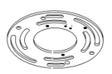 | Crossbar | 1
B | 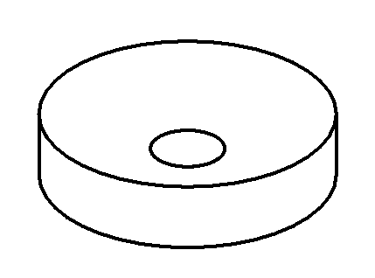 | Ceiling cap | 1
C | 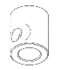 | Wire locking buckle | 1
D | 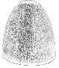 | Shade | 1
E |  | Socket | 1
F | 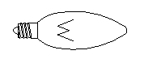 | Bulb | Not included

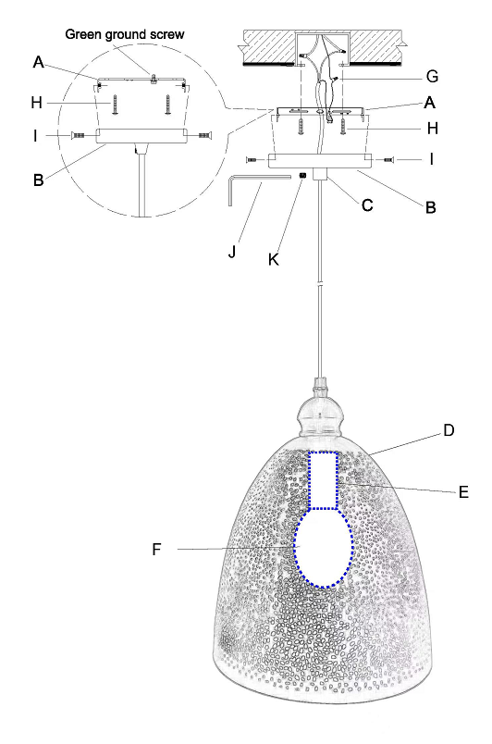

Hardware List
Part code | Component | Description | Qty
G | 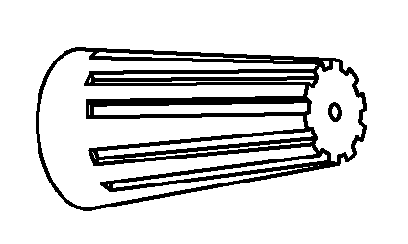 | Plastic wire nut connector | 3
H | 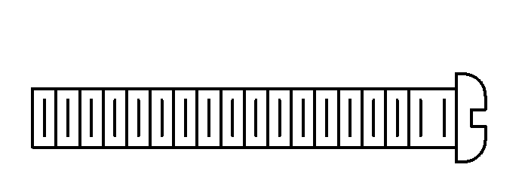 | Mounting screw G5/32-T32 L30 | 2
I |  | Mounting screw  G8/32-T32L32 | 2
J | 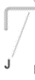 | Spanner | 1
K | 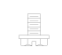 | Kim-Clinch | 2

Assembly Instructions:
Step1：With the help of another person to hold the weight of the lighting fixture, attach the crossbar (A) onto the electrical junction box by using 2 mounting screws (H).
Step 2: Connect ceiling cap (B) with the crossbar (A) tighten by using 2 mounting screws (I).
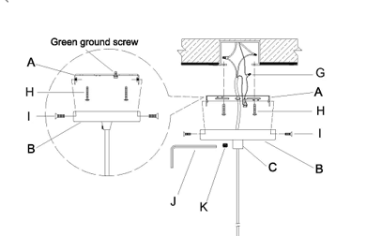

Step 3: Lock the Wire locking buckle (C) with the Kim-Clinch (K) by Spanner (J).
Step 4: Gently screw the bulb (not included) to the socket.
Step 5: Assembly is completed.

