

ASSEMBLY INSTRUCTIONS
Mililani Flush Mount (Item#II152-0142)
Caution:
- FOR YOUR SAFETY: Turn off the power to main electric circuit/ fuse box before beginning work.

Important Safety Instructions:
- Professional installation is recommended for hardwired lighting. Incorrect installation can lead to fires.
- These instructions are provided for your safety. It is very important that they are read carefully and completely before assembling fixture.
- We strongly recommend that two people install the lighting fixture.
- This fixture has been rated for up to (3) 60-watt maximum TYPE A bulbs (not included) or (3) 13-watt compact fluorescent light bulbs (not included). To avoid the risk of fire, do not exceed the recommended wattage.
- This lighting fixture is intended for indoor, residential use.

Warning:
- To reduce the risk of fire, electrical shock or personal injury, do not turn on lighting fixture until light bulb is installed and assembly is complete.
- Always turn off the lighting fixture and allow it to cool before replacing the light bulb.

Care instructions:
- Do not polish or use harsh cleaners as they may damage the finish.
- Wipe clean with a non-colored, lint-free soft, dry cloth.

Page 1 of 4

Pre-assembly:
- Remove all parts and hardware from box along with any plastic protective packaging.
- Check that all parts listed are included.
- Do not discard any contents until after assembly is complete to avoid accidentally discarding small parts or hardware.

Component List
Part code | Component | Description | Qty
A | 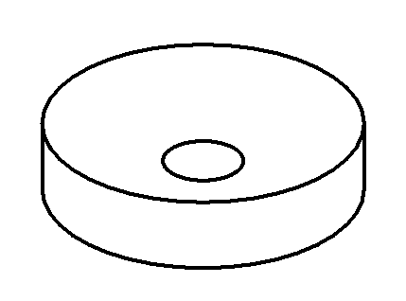 | Ceiling cap | 1
B | 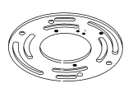 | Crossbar | 1
C | 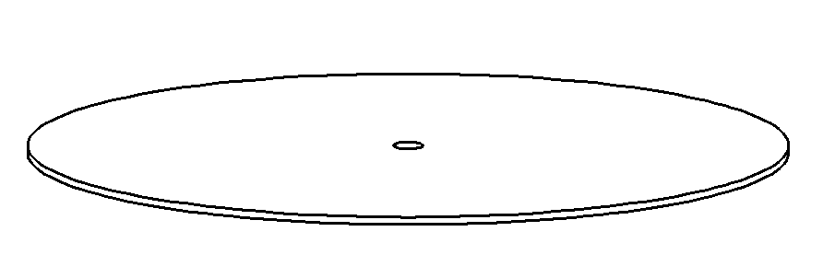 | Glass light screen | 1
D | 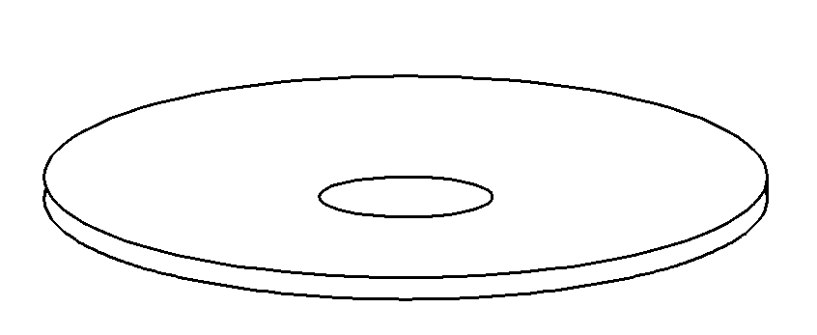 | Round metal patch | 1
E | 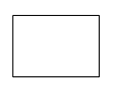 | Decorative cap | 1
F | 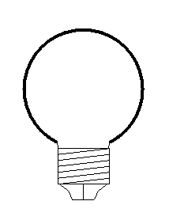 | Bulb | Not included

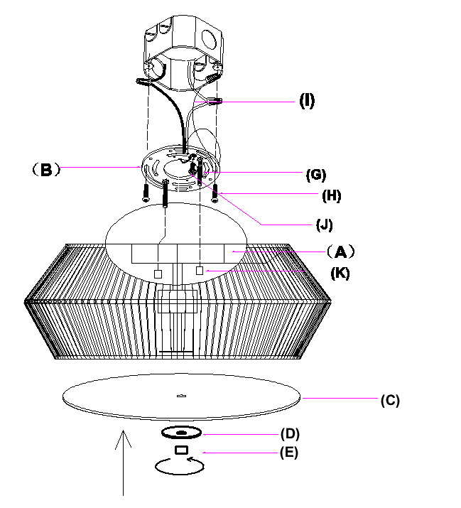

Hardware List
Part code | Component | Description | Qty
G | 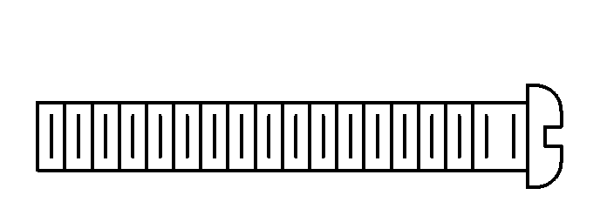 | Mounting screw G5/32-T32 L30 | 2
H |  | Mounting screw  G8/32-T32L32 | 2
I | 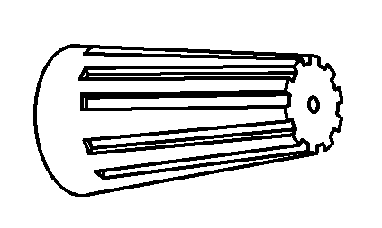 | Plastic wire nut connector | 3
J | 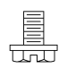 | Ground screw | 1
K |  | Nut cover | 2

Page 2 of 4

Assembly Instructions:
Step1：With the help of another person to hold the weight of lighting fixture, attach the crossbar (B) onto the electrical junction box by using 2 mounting screws(H).
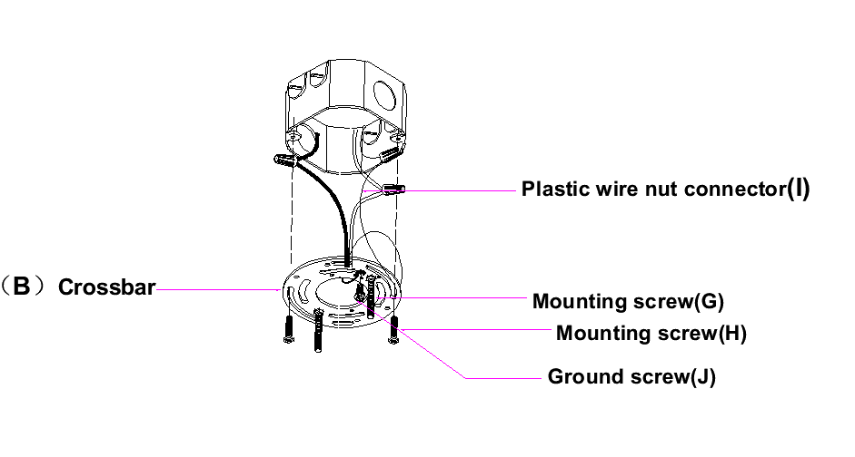

Step 2: Connect the ceiling cap (A) with crossbar (B), tighten by using the nut cover (K) using the 2 mounting screws (G), and install the bulb (F not included).
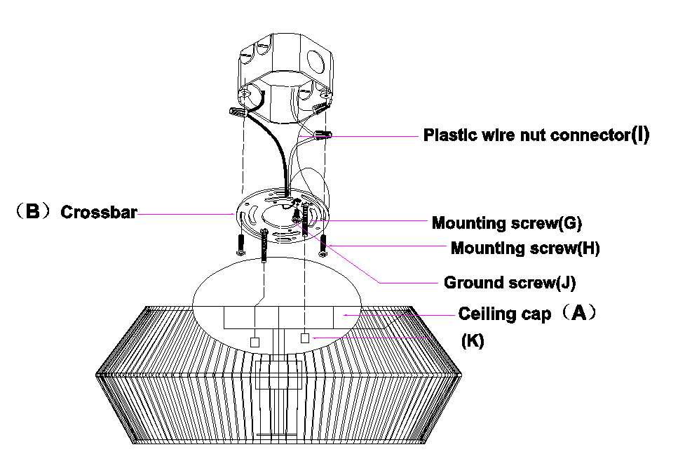

Page 3 of 4
Step 3: Position the glass light screen (C) upwards towards the fixture. After positioning the glass screen, insert the round metal patch (D), and tighten it with the decorative cap (E)

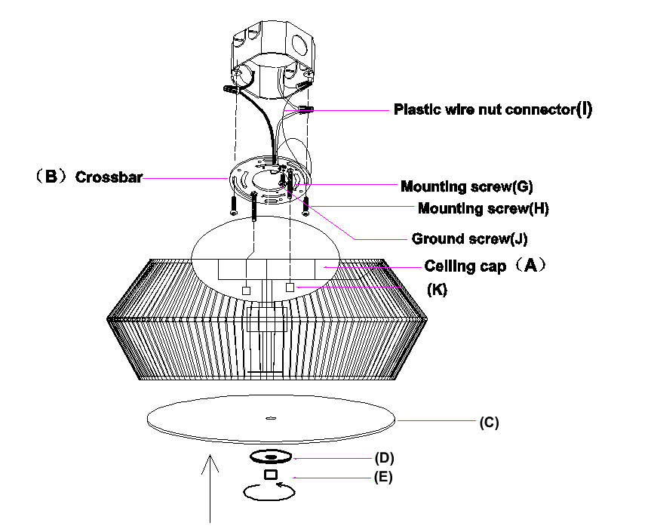
Thank you for your purchase

Page 4 of 4

