
ASSEMBLY INSTRUCTIONS

Ellis Chandelier (Item#: MT150-0032)
Important Safety Instructions:
- We recommend you contact a professional electrician to install any hardwired lighting. Incorrect installation can lead to fires.
- These instructions are provided for your safety. It is very important that they are read carefully and completely before assembling fixture..
- This fixture has been rated for up to (3) 40-watt maximum type B bulbs or (3) 7W 120V B11 CFL bulbs (not included). To avoid the risk of fire, do not exceed the recommended wattage.

Pre-assembly:
- Do not discard any contents until after assembly is complete to avoid accidentally discarding small parts or hardware.
- Remove all parts and hardware from box along with any plastic protective packaging.

Parts Enclosed: Hardware Included:
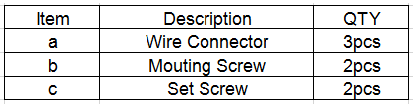
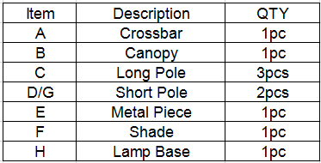

To install you will need: Screw driver/Electrical tape

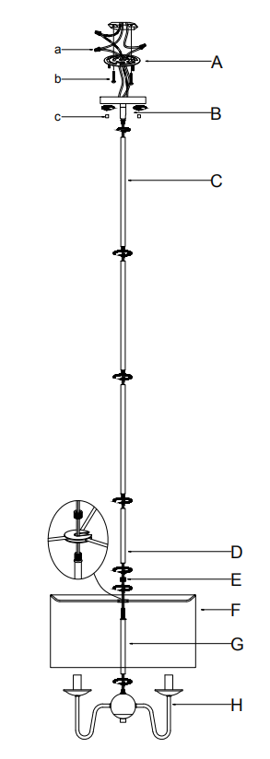

Care instructions:
• Wipe with soft dry cloth only
• Always avoid the use of harsh chemicals or abrasive as they may damage to the finish.

Thank you for your purchase

