Evaluation User Guideline

How to Log into EEC
- In IE browser, type the address www.eecsystem.com.
- In EEC Login Page, type your User Name, Password and Check Code. (See Figure 1-1). EEC Helpdesk will send your login user name and password if you do not have an account. If you have a user ID but forgot the password, please click Forgot Your Password to reset your password.
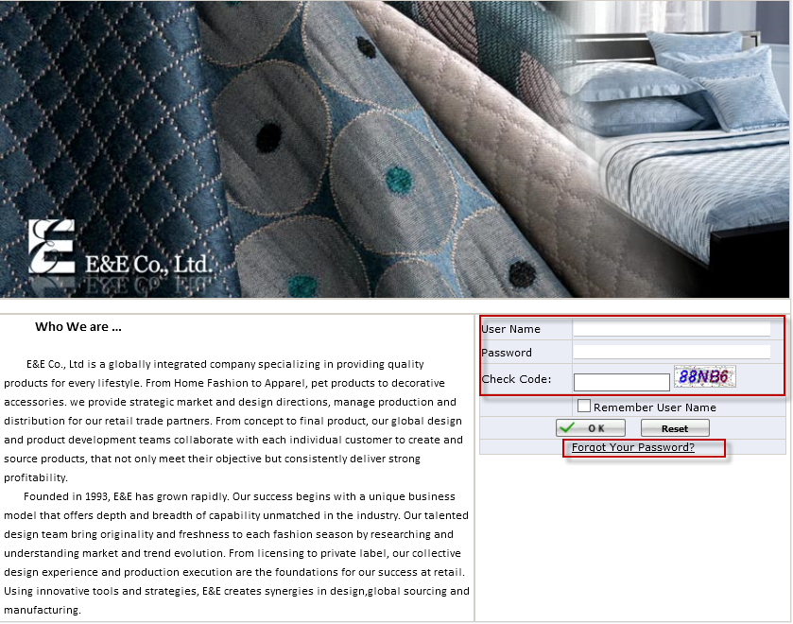
Figure 1-1 EEC Login Page

How to Go to Evaluation Application
- Click Evaluation Application under Evaluation. (See Figure 2-1)
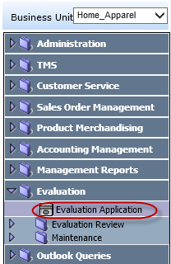
Figure 2-1 Evaluation Application Page Path

- It will open Evaluation Application Page. (See Figure 2-2)
(See Appendix A for Evaluation Application Page Introduction)
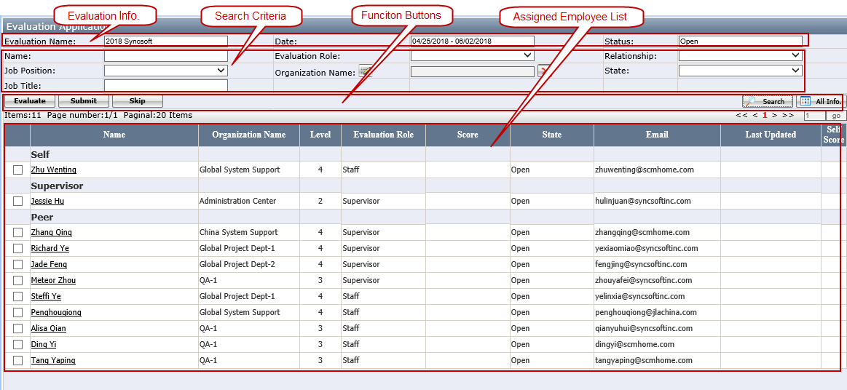
Figure 2-2 Evaluation Application Page

How to do the Employee Evaluation

How to Do Self Evaluation
You are required to do self-evaluation. It is mandatory.
- Click your name under Self section.
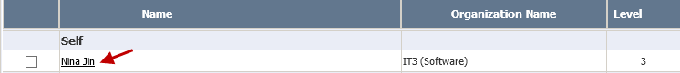

- It will open to open the Evaluation Application Detail Page. (See Figure 3-1)
(See Appendix B for Evaluation Application Detail Page Layout Introduction)
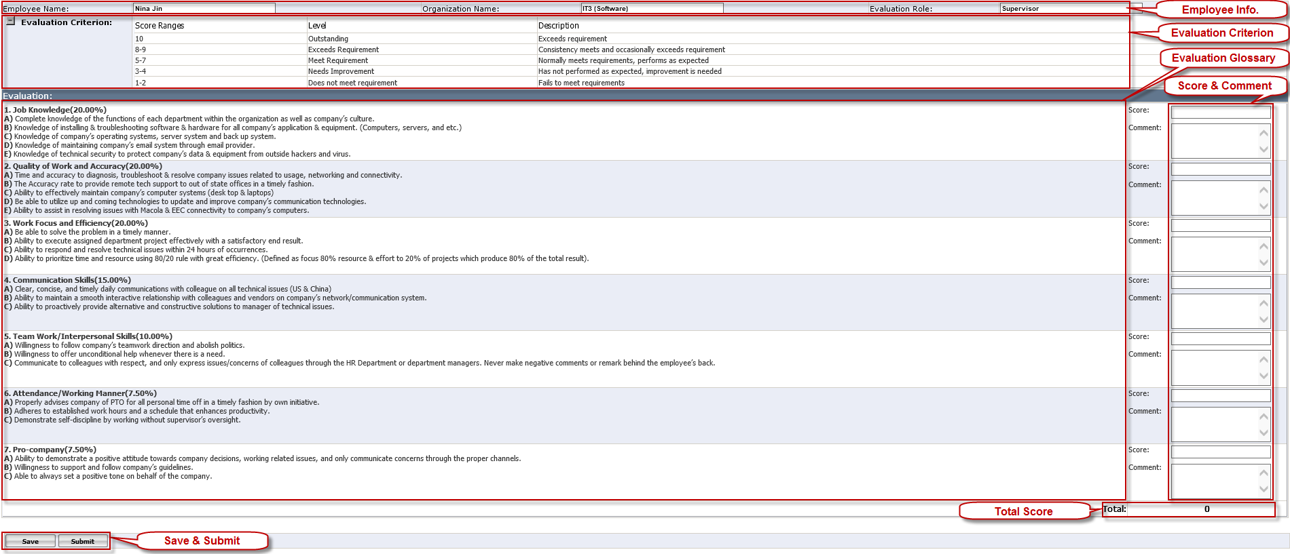
Figure 3-1 Evaluation Application Detail Page Layout

3) Enter Score between 1 and 10 for each subject and click Save. (See Figure 3-2)
- Comment is required for the the score is lower than 4.0 or higher than 9.5.
- The total score formula is Sum of (Score of each subject * Score Percentage of each subject).
- Self-Review Summary and Comments & Suggestion are optional
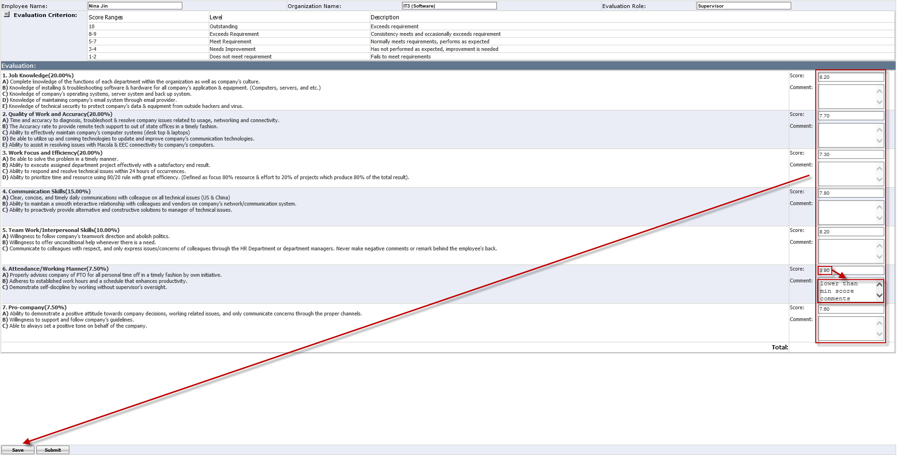
Figure 3-2 Self Evaluation Page with the entered score

- Once it is saved successfully, you can review the system automatically calculated total score at the bottom right. (See Figure 3-3) 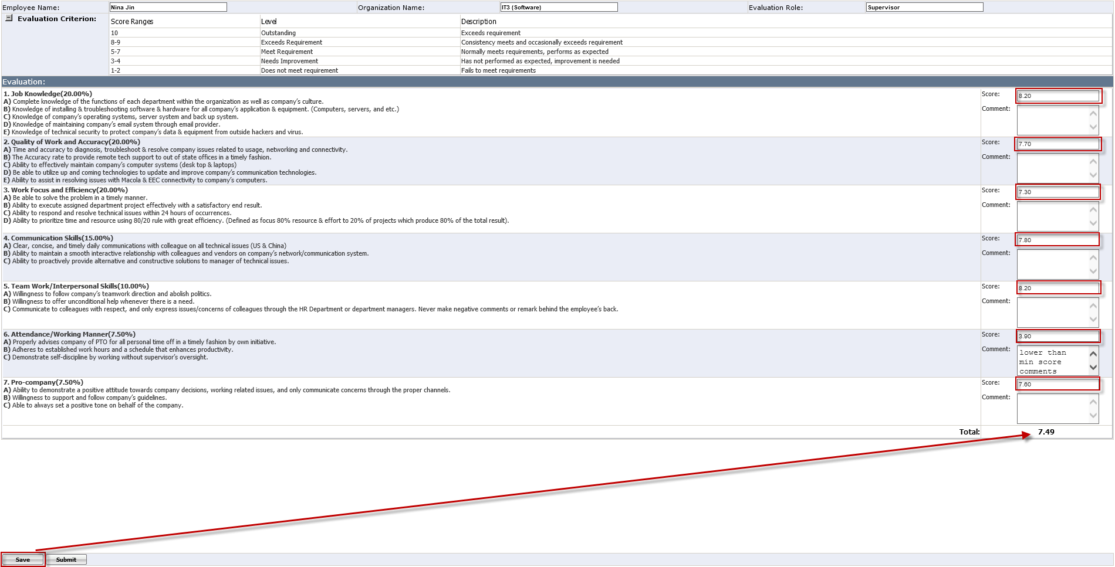
Figure 3-3 Self Evaluation Page with Total Score

- Click Submit to submit the score. You will get the warning message below since the evaluation application cannot be modified after it is submitted.
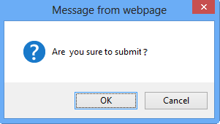
- If you click OK, the score will be submitted and you will get the successfully submit message below.
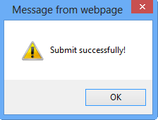
- If you click Cancel, it will be not submitted. You can make further changes and submit it to HR whenever you are ready. (See How to Submit Multiple Evaluations)

- Once it is submitted, Submit and Save button will be greyed out and the status will also change to “Close”. You cannot make further changes.

How to Do Supervisor / Subordinate / Peer Evaluation
- You are HIGHLY recommended to evaluate Supervisor. You can be assured that all your evaluation input will be kept 100% ANONYMOUS. (See Evaluation Result)
- Subordinates evaluation is required.
- It is not mandatory to perform peer evaluation. However, your participation is highly recommended & appreciated. You can skip the peers who you are not familiar with. (See How to Skip Peers) or leave it without submit the evaluation if you will work with them in the near future.
- Click the name under Supervisor ( Or Peer, or Subordinate ) section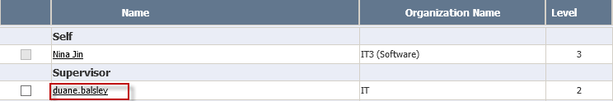

- It will open the Evaluation Application Detail Page. (See Figure 3-4)
(See Appendix B for Evaluation Application Detail Page Layout Introduction)
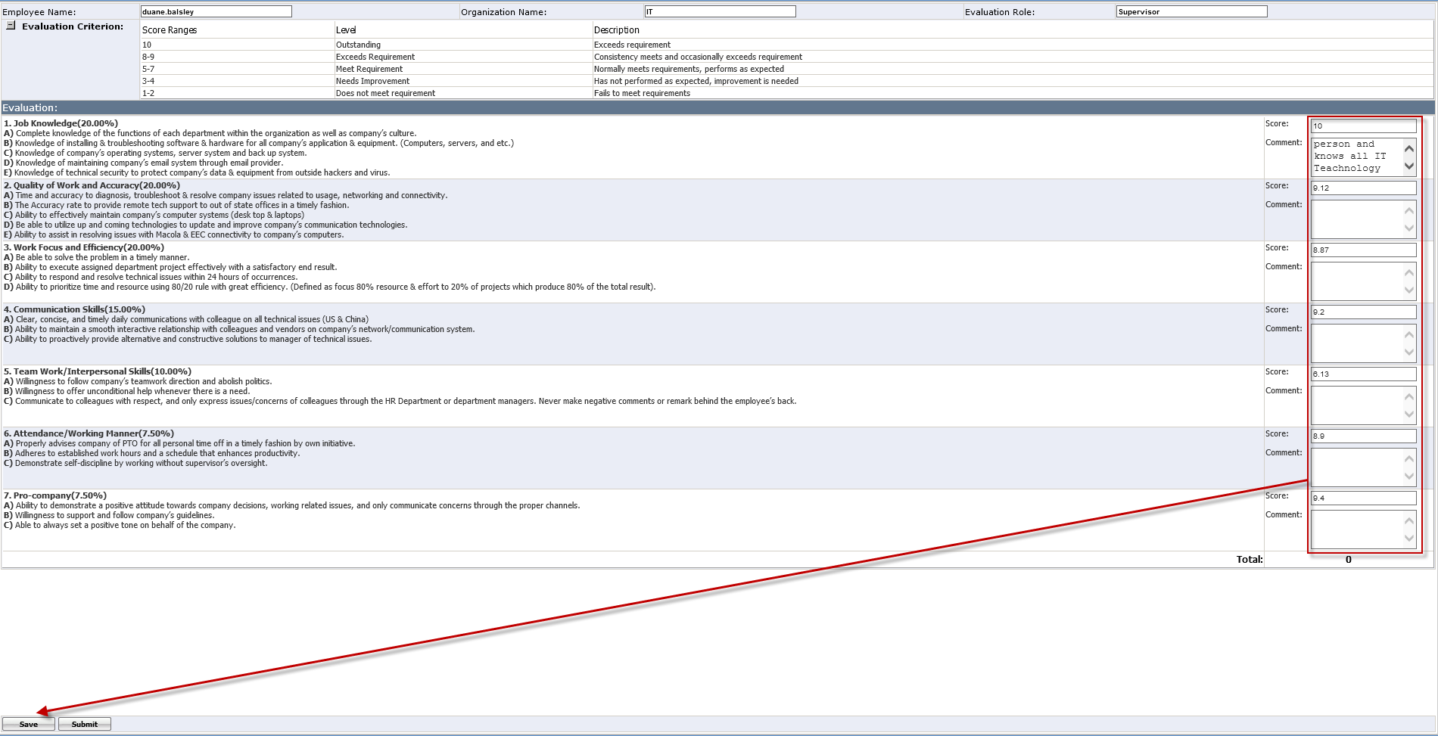
Figure 3-4 Supervisor Evaluation Application Detail Page Layout
- Follow the same step as < Self Evaluation > step 3 – 5, to enter score in each required subject. Click Save to save the score, then, whenever you are ready you can submit to HR. (See How to Submit Multiple Evaluations)

How to Filter the Team or Employee to Evaluate
- Filter the Team
- Click the organization selection icon in Search Criteria.
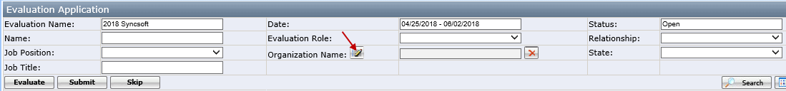
- Select an organization(s) which you would like to evaluate in the popup window and click OK.
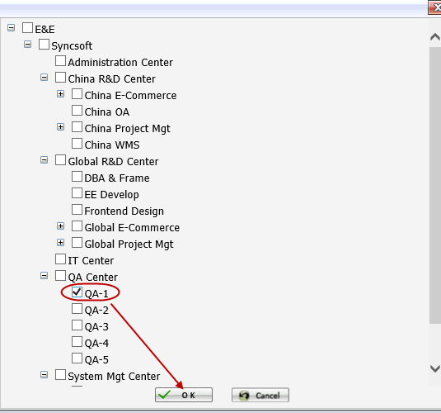
- Click Search button and the grid will list all the employees who are under the selected organization(s).
- Filter the employee
- Put the name in Name field.
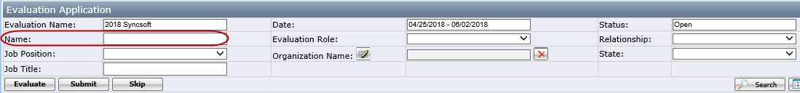
- Click Search button, the employee will list in the gird.
There are other criteria can be used to search user. More Detail, please see Search Criteria.

How to Do Multiple Subordinate or Peer Evaluations
You can also select multiple Subordinates or Peers to do the multiple evaluations at once which can help you to compare and save time.

- Put the multiple checks for names under Subordinate section or under Peer section, and click Evaluation. (See Figure 3-5)
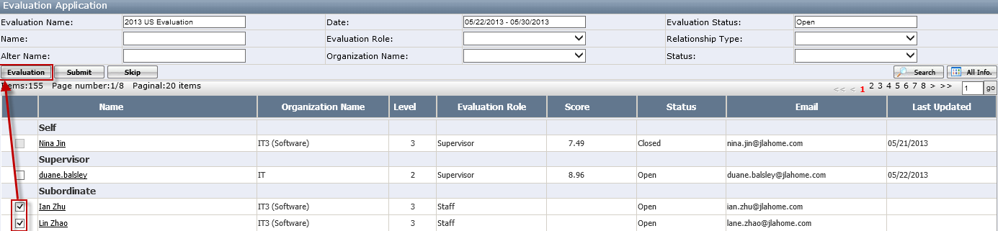
Figure 3-5 Select Multiple Subordinates / Peer Selection

- It will open the Evaluation Application Score Detail page for multiple subordinates. (See Figure 3-6) By default, it depends on your computer screen, you may only see the first three or four names. If you have more people than it displays, you can simply move the horizontal scroll bar to right in order to see & enter score for more names. There is no Max names you can select to do multiple evaluations.
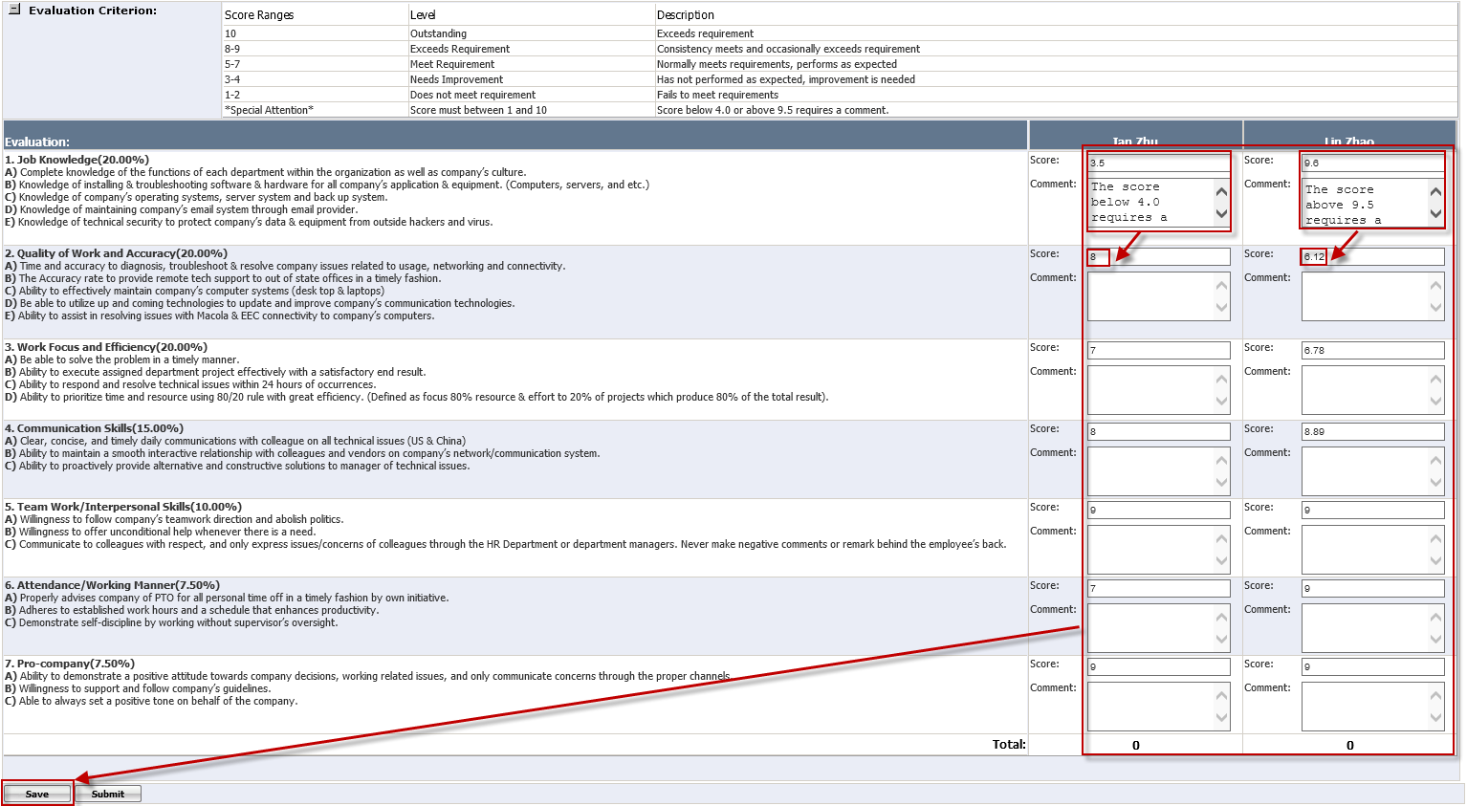
Figure 3-6 Evaluation Page for Multiple Subordinates Layout
- Follow the same step as < Self Evaluation > step 3 – 5, to enter score in each required subject. Click Save to save the score and then, whenever you are ready you can submit to HR. (See How to Submit Multiple Evaluations)

How to Submit Multiple Evaluations
To submit the multiple evaluations which you have only saved, but not have been submitted to HR yet.

- Click Submit, it will open the Submit User Page. (See Figure 3-7)
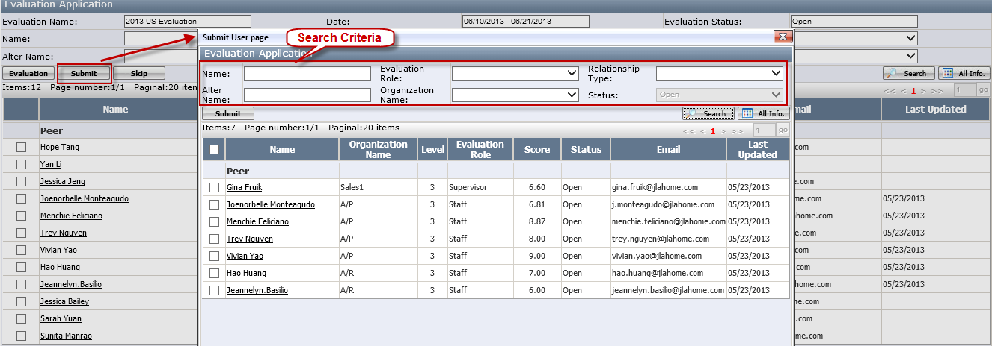
Figure 3-7 Submit User Page

- This page will list all employees you have saved the scores before. You can use the top Search Criteria to look for a particular employee to submit. (See Figure 3-7) Since the page layout is very similar as Evaluation Application Detail Page, please see Appendix B for Evaluation Application Detail Page Layout Introduction.

- Put the multiple checks for the names you want to submit the scores and click Submit. (See Figure 3-8) If you have more than one page, you can click the next page number to see the names you have saved scores.

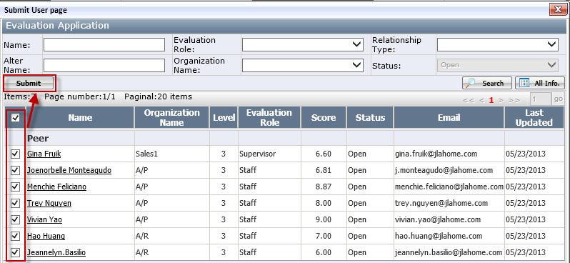
Figure 3-8 Submit User Page with Selected Names
- You will get the successful message below and click OK to close the message.
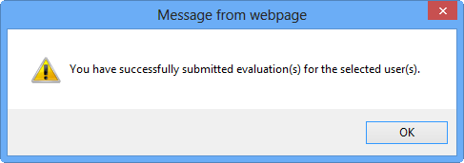

How to Skip Peers
For the peer that you are not familiar with, you can remove them from your peer list by skipping them or do not skip them and just do not do their evaluations since you might work with them in the near future. You can only skip peers which do not have the scores.

- Click Skip, it will open Skip User Page. (See Figure 3-9)
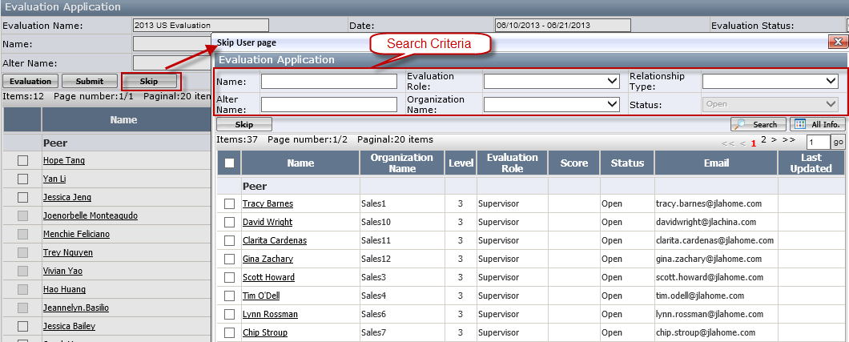
Figure 3-9 Skip Peer Page

- This page will list peer names who do not have the scores. (See Figure 3-9) You can use the top search criteria to look for a particular employee you want to skip. In the below example, it only list the sales organization peers. Since the page layout is very similar as Evaluation Application Detail Page, please see Appendix B for Evaluation Application Detail Page Layout Introduction.
- Put the multiple checks for the names you want to skip and click Skip. (See Figure 3-10)
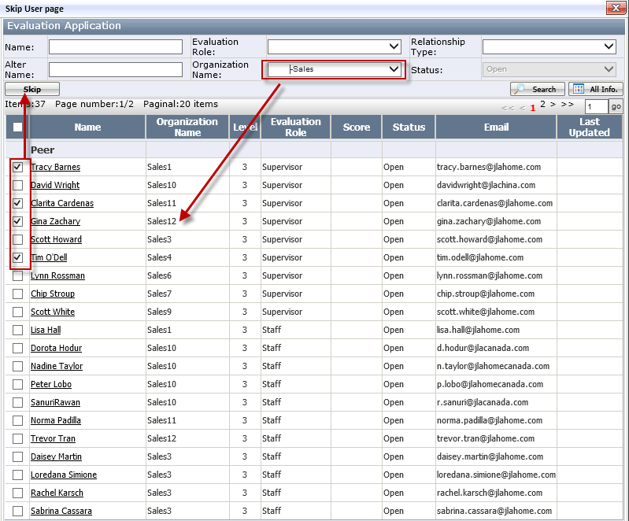
Figure 3-10 Skip Peer Page with Selected Name

- You will get the warning message below and click OK.
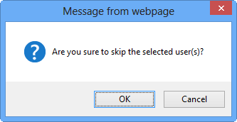
- Once it is successfully skipped, you will see the message below. System will automatically remove them from your peer list. However, your name will not be removed from their peer list. Therefore, you will still be evaluated by those you have removed from your peer list.
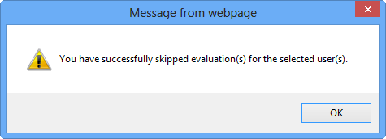

How to go to your Evaluation Result
- Click Self Review page under Evaluation Review of Evaluation Module (See Figure 4-1)
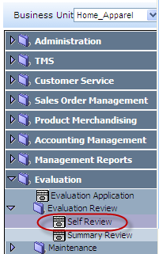
Figure 4-1 Self Score Page Path

- It will open Self Review page. This page allows the employees to review the self score. (See Figure 4-2)
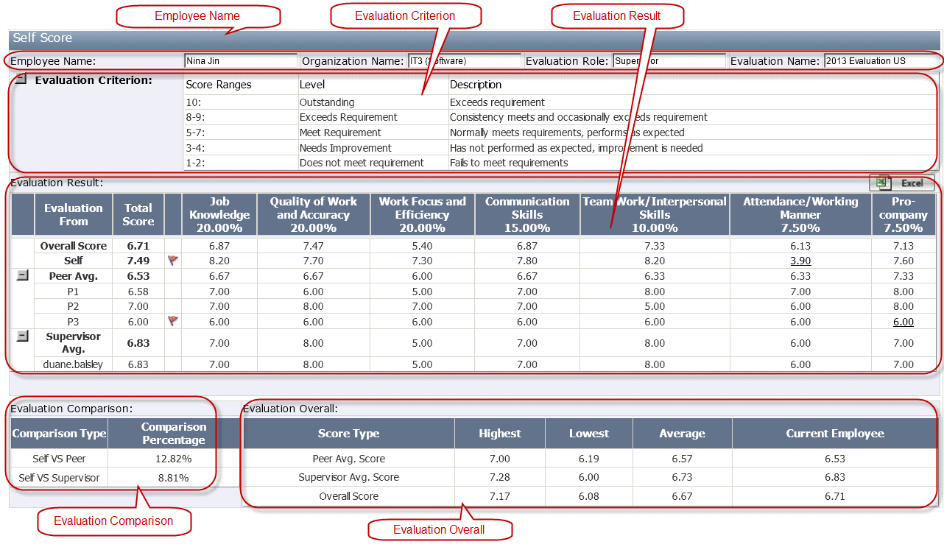
Figure 4-2 Self Review
Note: When the evaluation is in "Open" status, the score is not finalized. When the employee click this page, it will get a warning message below. If the employee click OK, it will open "Self Review" page. (See Figure 4-3). If it in “Close” Status, it is the final & accurate score. If it in “Complete” Status, the score is archived and you cannot review it any more.
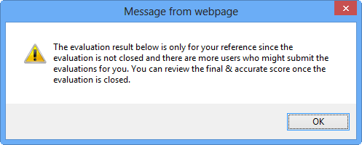
Figure 4-3 Self Review warning message for the open evaluation.

How to read your Evaluation Result
You can see Total Score of Overall Score, Self, Peer Ave. and Supervisor Avg. and Average Score for each subject. (See Figure 4-4)
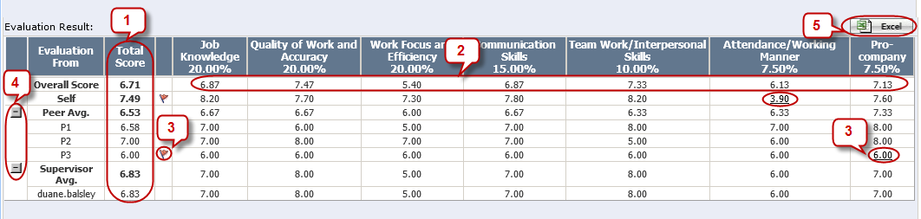
Figure 4-4 Evaluation Result

- Total Score
Peer Avg. = (P1 total+P2 total+…)/Total Peer Number
Supervisor Avg. = (Supervisor1total+Supervisor2 total+…)/Total Supervisor Number
Overall Score = Peer Avg. * 40% + Supervisor Avg. * 60%
Self = Sum of (Score of each subject v* Score Percentage of each subject).
Note: To keep the evaluation result to be 100% ANONYMOUS, all subordinate scores will account as a part of peer score. Peer names will displayed as "P1", "P2" etc.

- Average Score for each subject = Peer Avg. of each Subject * 40% + Supervisor Avg. Of each Subject * 60%

- Comment Flag
If there is any score has a comment, it will have a red flag (). You can click the score which has the hyperlink to review the comment. (See Error! Reference source not found.). The score is less than 4.0 or higher than 9.5 will have a comment.
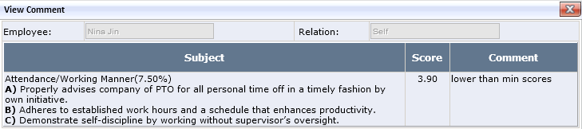

- Collapse / Expand
Click / icon to hide or display the detail score for Peer Avg. or Supervisor Avg.

- Excel
It is used to export Self Score to an excel file.

Evaluation Comparison
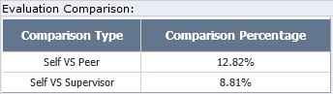
Self VS Peer: (Self -Peer Avg.)/Self * 100%.
- If the percentage is positive, it means Self-score is higher than Average Peer Score.
- If the percentage is “0”, it means Self-score is equal to the Average Peer Score.
- If percentage is negative, it means Self-score is lower than Average Peer Score.

Self VS Supervisor: (Self -Supervisor Avg.)/Self * 100%.
- If percentage is positive, it means Self-score is higher than Average Supervisor Score.
- If the percentage is “0”, it means Self-score is equal to the Average Supervisor Score.
- If percentage is negative, it means Self-score is lower than Average Supervisor Score.

Evaluation Overall
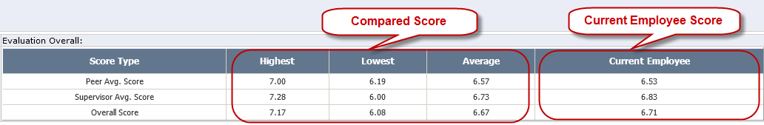
Figure 4-5 Evaluation Overall

Compared Score
It will list the Highest, Lowest and Average of Peer Avg. Score/ Supervisor Avg. Score / Overall Score.
Note: For the Regular Employee, it compares the employees having the same report department. For the Executive employee, it compares the employees having the same “Executive” role.

Current Employee Score
See Overall Score, Peer Ave. Score and Supervisor Avg. Score in Total Score of Evaluation Result.

Where to Get the Help If You Have Question or Problem
If you have any questions and issues during the evaluation process, please sent email directly to eechelpdesk@jlahome.com or you can always chose to contact HR at hrdept@jlahome.com for their assistant.

Appendix A: Evaluation Application Page Introduction
(See Figure 2-2 Evaluation Application Page Layout)

Evaluation Info.
- Evaluation Name: Name of Annual Employee Performance Evaluation.
- Date: Start date and end date of Annual Employee Performance Evaluation.
- Status: The status of Annual Employee Performance Evaluation. If it is in Open status, you can submit the evaluation application. If it is in Close or Pending status, you can have the read only access. If it is in Complete status, you cannot access it since it has been archived by HR.

Search Criteria
You can search for a particular employee you want to do the evaluation.
- Evaluation Role: It is the evaluation role assigned to each employee such as Staff and Supervisor.
- Organization Name: It’s the organization which the employee belongs to. If you want to see all employee under IT, you can simply select the organization “IT.
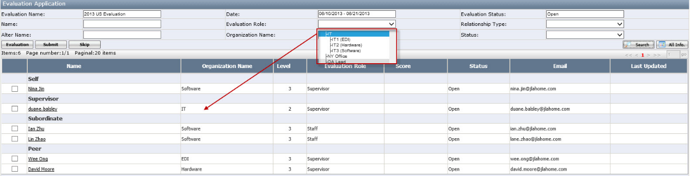
- Relationship Type: The relationship of the employees assigned to you such as “Peer”, “Subordinate”, “Supervisor” and “Self”.
- Status: “Open” means the evaluation has not been submitted and “Close” means it has been submitted.

Assigned Employee List
- Checkbox: Use to select the employees to do the multiple evaluation. It will be greyed out once the evaluation application is submitted.
- Name: Employee name and you can open the employee evaluation page by clicking it.
- Level: It is the level of the organization name.
- Score: The score given to an assigned employee.
- Pagination: You will see the pagination if you have more than 20 employees assigned to you.

Appendix B: Evaluation Application Detail Page Layout Introduction
(See Figure 3-1 Evaluation Application Detail Page Layout)

- Employee Info.: Employee Name, assigned Organization Name and Evaluation Role.
- Evaluation Criterion: The score range for each subject. (See Figure 7-1) You can click/button to hide/show it.
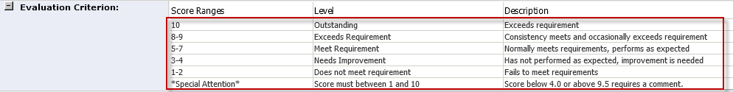
Figure 7-1 Evaluation Criterion

- Evaluation Glossary: The evaluation glossary assigned to each organization. The glossary contains several subjects. Each subject has several Contents. The Score Percentage for each subject is located at the end of the subject. Supervisor and staff might have the different glossaries. (See Figure 7-2)

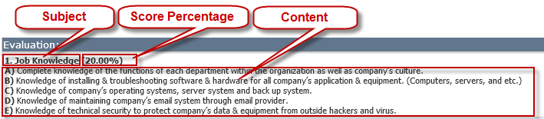
Figure 7-2 Glossary Definition

- Score & Comment: It is requried to enter the score for each subject. The score must be between 1 and 10. If the score is lower than 4.0 and higher than 9.5, the comment is requried. (See Figure 7-1 Evaluation Criterion)
- Total Score: System will automatically calculate it. The formula is Sum of (Score of each subject*Score Percentage of each subject).
- Save & Sumbit: Save the score and submit it.

